Code Review: I2301366
Reviewer: James Wood
Date: December 8th, 2023

Bugs
- It seems like this won’t work for work orders with more than one line, or rather, will create erroneous DocStorage records. Since it’s no longer filtering by DetailID, all details will be returned by the query, but the saving only references the passed in DetailID. What was the impetus for this change? This code is from clsWorkOrderFormLibrary.
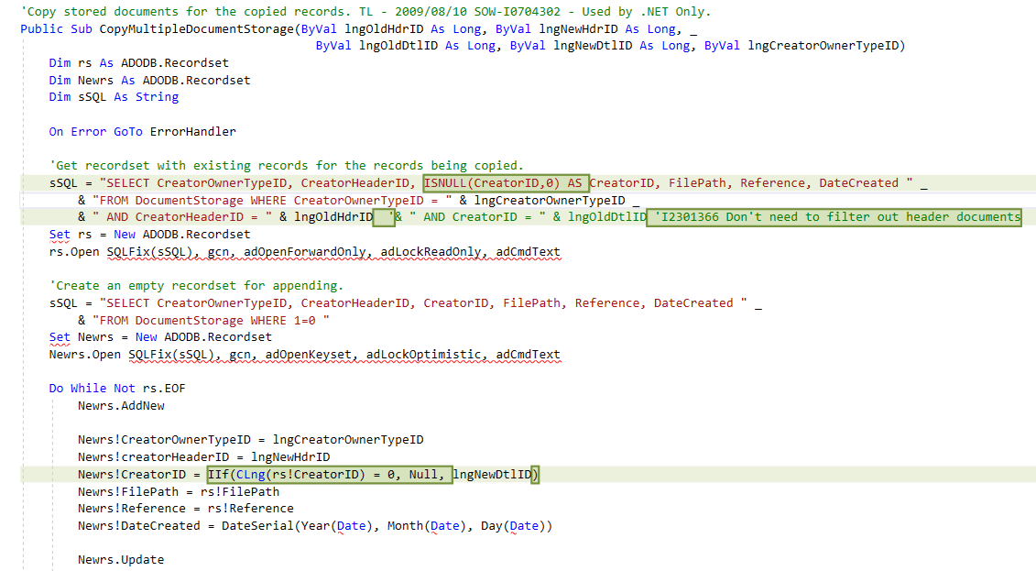

Preventative Action/Safety

Design/Architecture (Duplication, appropriate project, namespaces, maintainability)

Data Model (Naming, good design, needs index?)

Performance (Minimize DB hits, excessive loops, queries, scalable)

UI (Alignment, naming, standardization, tab order)

Error Handling (Behind events, appropriate parameter checking)

Cleanup (Dispose code, remove handlers, large data objects)

Readability (Well-named variables, methods, clear algorithm, is it understandable)

Comments (Useful, explains why rather than how)
- If you would like to leave this comment here, I would give it a little more detail. Tell the future developer why we are zeroing it out later, instead of just saying what we’re doing. Comments should explain “why it’s doing this” not “what it’s doing”.
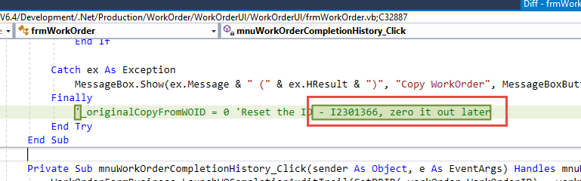
Having said that, I think it would be fine to just blow that whole Finally block away and forget it ever existed.

Message Boxes (Grammar, spelling, captions, appropriate icons)

Ticket Management (Release Branch?, Testing Notes)

Extras

